NAME : K.Yamini Joshna

REGISTER NUMBER : 192110710

COURSE CODE : CSA0520

COURSE NAME : DATABASE MANAGEMENT FOR DATA ANALYTICS

**SELECT with various clause – GROUP BY, HAVING, ORDER BY**

##### Questions:

GROUP BY - HAVING

1. How many students are registered for each course? Display the course description and the number of students registered in each course.
2. How many courses did each student register for? Use Assessment table.

ORDER BY

1. Retrieve Name, Gender, MobileNo of all the students in ascending order of RegNo.
2. List the faculty members in the order of older faculty first.

##### OUTPUTS:

1)

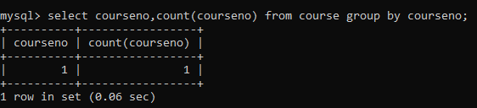

2)

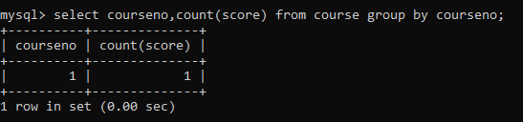

3)

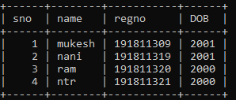

4)

